Progress test 4 Math’s symbols & Computing
V – 1
Name: _________ Total scores: ____ (47/97%)

  - Listen to the teacher explaining the diagram to her students and complete the diagram. (Infotech.St.b.Un.3.Task 5.)
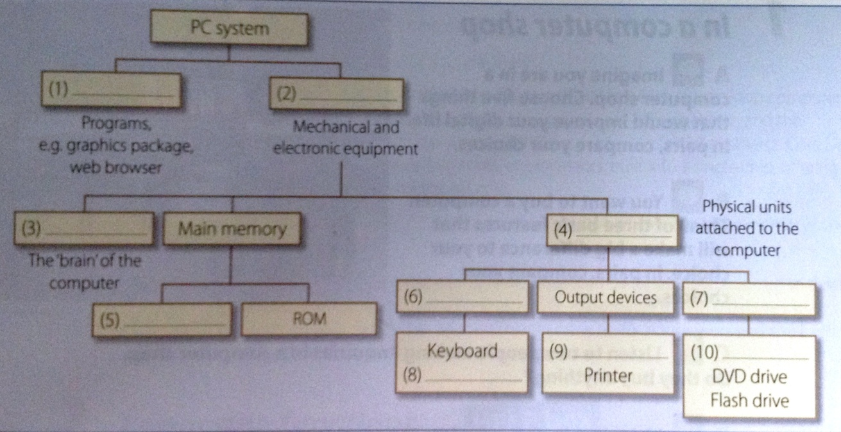
- ______________ 6. ______________
- ______________ 7. ______________
- ______________ 8. ______________
- ______________ 9. ______________
- ______________ 10. _____________
10

  - Rewrite the active sentences into passive ones.
      - Korea made this engine. ____________________________
      - Students designed the car on computer with a GAD program.
__________________________________________________
      - Secretary put me through to Dr. Margulies very soon.
__________________________________________
      - A new virus infects computers for several minutes.
__________________________________________
      - Helen won’t sign the agreement.________________________
      - She put away secret disks and papers.____________________
      - Claude usually wins Maths’ competitions.
__________________________________________________
      - I’ll print out the report for tomorrow. ___________________
______________________________________
8
  - Put the verbs in brackets into passive form.
      - This game ________________ (play) by people of all ages.
      - My camera ___________ (steal) by someone two days ago.
      - Networks _________________ (connect) via satellite.
      - The letter ___________ (receive) last week.
      - The book _____________ (devote) by me to my best friend.
      - Many people__________ (rescue) by fire-fighters last night.
      - The streets____________ (clean) by yardmen every day.
      - The first telephone __________ (invent) by Antonio Meucci.
      - I hope the bill _____________ (pay) by you next time.
9
  - Complete the sentences.
- She reads her emails on the ……… of her computer.
- A small portable computer is a ………
- Using a printer, you get a hard ……… .
- The information in your computer is on the ……… disk.
- I threw out the old mouse ………. . I need a new one.
- The … (•) is written above the line.
- The sign of approx. (≈) is read “is ………………… equal to”.
- 10: 5 = 2 is read “ten divided ……… five is two”.
- This grouping sign ( ) is named …………… .
- The sign “… to 60” is read “……………..”.
10
  - What do these abbreviations stand for?
- RAM – __________________________
- MHz – __________________________
- PC – ____________________________
- Mac OS – ________________________
5
- ROM – __________________________

  - Fill in the verbs from the box in the correct form. Be careful there is an extra verb you don’t need to use.
log turn shut plug power print
      - I have to wait for my computer to ______ on. It usually takes a couple of minutes to get it started. 2. I forgot my password and couldn’t ______ in to my account. 3. You have to ______ in the power cable to charge your laptop battery. 4. When you finish typing, make sure you _____ down the computer. 5. You need to ______ up the computer to get started with your presentation.
5
Progress test 4 Math’s symbols & Computing
V – 2
Name: __________ Total scores: ____ (47/97%)

- Listen to the teacher explaining the diagram to her students and complete the diagram. (Infotech.St.b.Un.3.Task 5.)
- ______________ 6. ______________
- ______________ 7. ______________
- ______________ 8. ______________
- ______________ 9. ______________
- ______________ 10. _____________
10

- Rewrite the active sentences into passive ones.
      - People set up this church in 1737.______________________
      - I attached these files to the email. _____________________
      - The Japanese make these microchips.
_________________________________________________
      - I will use Math’s symbols in my essay.
_______________________________________
      - They don’t deliver the post on Sundays.
________________________________________________
      - His friend showed me an interesting I-Tech shop.
________________________________________________
      - My nephew broke my scanner.________________________
      - She easily picks up foreign languages.
8
_______________________________________
- Put the verbs in brackets into passive form.
      - I __________ (ask) at the lesson yesterday.
      - The vehicle ___________ (test) at the track next week.
      - GPS __________ (develop) in the 1970s as a military navigation system.
      - The exams generally __________ (mark) by two examiners.
      - We ________ always ________ (wake) by the alarm.
      - My laptop __________ (fix) tomorrow.
      - A serious error (find) _________ in the program.
      - Radio waves (discover) _______ in 1887 by Heinrich Hertz.
      - In the near future, the Internet and other IT devices ___________ (introduce) into cars.
9

- Complete the sentences.
- The sign (∴) is named the sing of …………… .
- The enclosing sing { } is read as …………. .
- The sign (≠) is read “is ………… to”.
- This symbol (>) is read “is …………… than”.
- If your printer is on, can you do some …………… .
- You can keep a copy of information from your computer on a ….…
- I type information using the ………… .
- The brain of the computer is …………… .
- The CPU, modem, CD-ROM and hard disk are inside the ……….
- ………. include storage device and input / output devices.
10
- What do these abbreviations stand for?
- GB – ____________________________
- CD-ROM – _______________________
- BIOS – ___________________________
- Unix OS – ________________________
- ROM – ___________________________
5

- Fill in the verbs from the box in the correct form. Be careful there is an extra verb you don’t need to use.
log turn print type go plug
      - I _____ on to my bank account to check my balance. 2. His scanner didn’t work because he forgot to _____ it in to a socket. 3. If you want to _____ out the document, boot up the computer. 4. When my PC _____ down I had to reboot it to go on working. 5. If you want to get into the club, _____ in your personal code.
5

